CHAPTER ONE
INTRODUCTION
1.1 BACKGROUND OF THE PROJECT

The logistical problems associated with distributing, collecting, grading, and returning assignments and the difficulties in ensuring fairness and consistency in grading tends to increase non-linearly with the number of students enrolled in an academic program.Nowadays, we are living in an information age dependent upon digital Information retrieved from the internet. This Digital information is electronically interpreted,the results of the computer processed information. (Curtis et al., 2008) Different type of jobs relies mostly on the internet to get information, using it, managing it, and relaying information to others. Computers enable the efficient processing and storage of information.Computerized-assisted grading system will go a long way in guiding the grading process and compilation of final results among systems of any institution in Nigeria. Ekpenyong report that using computer-assisted grading systems during bulk students grading with large amount of students reduced the grading time by half compared to traditional hand grading without the help of the system (Ekpenyong, 2008). In addition to the “reduced time in grading assignments,” Czaplewski notes that computer-assisted grading system can lead to increased “validity and accuracy of grading – making grading more evenhanded,” increased feedback for students, and increased student satisfaction.This research work presents an online computerized system to assist in grading of students to improve the fairness, consistency, and efficiency of grading.
Many teachers feel that the time they take in recording and computing for the grades of their students is time that could be better spent elsewhere, like preparing lessons, researching or meeting with their students.

STATEMENT OF THE PROBLEM

The general statement of problem is to create a Computerized Grading Evaluation System for Gateway Polytechnic Saapade, to solve the following problems.
- To design and develop a comprehensive module that will display the student’s grade records easily,
- To implement grade automation awareness among schools by reducing (if not eliminating) manual tasks of grade keeping and finally To create a system that will automatically compute the student’s grade of university of Ibadan.

  - AIMS & OBJECTIVES OF THE PROJECT

The main objective of the study is to develop a Computerized Grading Evaluation System for University of Ibadan. With the following objectives –
- To create design and develop a computerized grade evaluation system for recording of student’s name, grade level and section.
- To create a system that will be secured and maintain the integrity of data, which can be easily retrieved
.

1.4 SIGNIFICANCE OF THE PROJECT

The computerized grade evaluation system will provide convenience to teachers through the easier and faster way of recording information. Population of students is ever increasing in alleducational institution so great demand in teaching force is also becoming higher. The online Grade evaluation System is very essential and important for school’s operations and goals. The students are graded to measure their performance in their academic courses and knowledge. Teachers spend a lot of time to accurately compute the grades of the students using their calculators, and, in earlier times, teachers manually solve grades using the manual computations means which is always filled of errors.

Acomputerized grade evaluation system for Gateway Polytechnic Saapade will provide a marked improvement in the way teachers’ record and compute for the grades of students.
Reduced cost: it reduces the cost of learning, examination, test, assignments and result processing institutions.

1.5 SCOPE OF THE PROJECT
The scope of the research is focused on designing and implementing a computerized grade evaluation system for Gateway Polytechnic Saapade. The project is designed using PHP, JAVASCRIPT and MySQL.

1.6 LIMITATIONS OF THE PROJECT

The major limitation of this research is related to student results and data which are very sensitive materials which can’t be disclosed to the general public, sourcing and getting student information to be used for this research work was a major limitation.

1.7 DEFINITION OF TERMS
CGPA : Cumulative Grade Point Average (CGPA) is an assessment tool used to evaluate your academic performance.
Evaluation: the making of a judgement about the amount, number, or value of something; assessment.
Database: database, also called electronic database, is any collection of data, or information, that is specially organized for rapid search and retrieval by a computer
Software: An application program is a computer program designed to carry out a specific task other than one relating to the operation of the computer itself
CHAPTER TWO
LITERATURE REVIEW
Evaluation gives an important yard stick to judge the quality of students. It plays a vital role in the educational system. It also offers motivation and a sense of purpose to both teachers and students to achieve set goals. (Mazza et al., 2004) The word examination has come to be associated with stress and anxiety. The practice of teaching and learning which is thought to be meaningful for the student loses its joy because of these negative connotations of examination. The larger context of education is to train futuristic citizens for a meaningful and productive life in a globalised society.
There is a dire need to build up the education system even more so in a pluralistic society which addresses itself to a heterogeneous group. (Stephen, 2002) Evaluation is a means of recognizing the extent to which we have been successful in imparting such an education. Evaluation is an essential part of the educational process as some form of assessment is compulsory to determine the effectiveness of teaching learning processes and their assimilation by learners. External examinations „are largely inappropriate for the „knowledge society‟ of the 21stcentury and its‟ need for innovative problem solvers‟, Questions if not framed well, “call for rote memorization and fail to test higher-order skills like reasoning and analysis, lateral thinking, creativity and judgment. External exams make no allowance for different types of learners and learning environments and induce an in-ordinate level of anxiety and stress”. (NCF- Position paper on Examination Reforms) Schools start ranking students, on the basis of their marks, from as early as their preprimary years. Such an impel has several negative effects on learning.
Students, parents and society at large become anxious in the race to attain more and more marks in examinations which leads to an extremely stressful existence. (Tata, 2005) Moreover, while all out efforts are made to improve the reliability of examination, the human error cannot be avoided. This inadequacy can be overcome if the students are placed in ability bands that represent range of scores. This calls for a functional and reliable system of School-Based Evaluation. There was a need to look at the holistic assessment of a learner which also includes co scholastic area of Life Skills, Values and Attitudes, Games and Sports as well as Co-Curricular activities. The Continuous and Comprehensive Evaluation scheme seeks at addressing this in a holistic manner. A number of National Committees and Commissions in the past have consistently made recommendations regarding sinking emphasis on external examination and encouraging internal assessment through School-Based Continuous and Comprehensive Evaluation. Therefore, the CCE scheme brings about a paradigm shift from examination to effective pedagogy. The National Policy on Education 1986 (NPE) and Programme of Action 1992 (POA) also envisaged the recasting of the examination system and has, inter alia, suggested that grades be used in place of marks. National Curriculum Framework 2005(NCF) envisaged an evaluation system which would grade the students on their regular activities in the classroom and enable students to understand and focus on their learning gaps and learn through these as part of Formative Assessment. National Curriculum Framework 2005, while proposing Examination Reforms has also stated – “Indeed, Boards should consider, as a long-term measure, making the Class X Examination Optional, thus permitting students continuing in the same school(and who do not need a Board certificate) to take an internal school exam instead “. Hon‘ble Union Minister for Human Resource Development also announced- ―Push the process of examination reform in accordance with NCF 2005. This will include making the Class X examination optional, thus permitting students continuing in the same school (and who do not need a board certificate) to take an internal school assessment instead.

2.2 COMPUTER BASED LEARNING
Computer-based learning, sometimes abbreviated to CBL, refers to the use of computers as a key component of the educational environment. While this can refer to the use of computers in a classroom, the term more broadly refers to a structured environment in which computers are used for teaching purposes. The concept is generally seen as being distinct from the use of computers in ways where learning is at least a peripheral element of the experience (e.g. computer games and web browsing).

2.3 COMPUTER BASED TRAINING
Computer-Based Trainings (CBTs) are self-paced learning activities accessible via a computer or handheld device. CBTs typically present content in a linear fashion, much like reading an online book or manual. For this reason they are often used to teach static processes, such as using software or completing mathematical equations. The term Computer-Based Training is often used interchangeably with Web-based training (WBT) with the primary difference being the delivery method. Where CBTs are typically delivered via CD-ROM, WBTs are delivered via the Internet using a web browser. Assessing learning in a CBT usually comes in the form of multiple choice questions, or other assessments that can be easily scored by a computer such as drag-and-drop, radial button, simulation or other interactive means. Assessments are easily scored and recorded via online software, providing immediate end-user feedback and completion status. Users are often able to print completion records in the form of certificates.
CBTs provide learning stimulus beyond traditional learning methodology from textbook, manual, or classroom-based instruction. For example, CBTs offer user-friendly solutions for satisfying continuing education requirements. Instead of limiting students to attending courses or reading printing manuals, students are able to acquire knowledge and skills through methods that are much more conducive to individual learning preferences. For example, CBTs offer visual learning benefits through animation or video, not typically offered by any other means.
CBTs can be a good alternative to printed learning materials since rich media, including videos or animations, can easily be embedded to enhance the learning. Another advantage to CBTs is that they can be easily distributed to a wide audience at a relatively low cost once the initial development is completed.
However, CBTs pose some learning challenges as well. Typically the creation of effective CBTs requires enormous resources. The software for developing CBTs (such as Flash or Adobe Director) is often more complex than a subject matter expert or teacher is able to use. In addition, the lack of human interaction can limit both the type of content that can be presented as well as the type of assessment that can be performed. Many learning organizations are beginning to use smaller CBT/WBT activities as part of a broader online learning program which may include online discussion or other interactive elements.

2.4 COMPUTER SUPPORTED COLLABORATIVE LEARNING (CSCL)
Computer supported collaborative learning (CSCL) is one of the most promising innovations to improve teaching and learning with the help of modern information and communication technology. Most recent developments in CSCL have been called e-learning 2.0, but the concept of collaborative or group learning whereby instructional methods are designed to encourage or require students to work together on learning tasks has existed much longer.
In Datacloud: Toward a New Theory of Online Work, Johndan Johnson-Eilola describes a specific computer-supported collaboration space: The Smart Board. According to Johnson-Eilola, a “Smart Board system provides a 72-inch, rear projection, touchscreen, intelligent whiteboard surface for work”. In Datacloud, Johnson-Eilola asserts that “we are attempting to understand how users move within information spaces, how users can exist within information spaces rather than merely gaze at them, and how information spaces must be shared with others rather than being private, lived within rather than simply visited”. He explains how the Smart Board system offers an information space that allows his students to engage in active collaboration. He makes three distinct claims regarding the functionality of the technology:
1) The Smart Board allows users to work with large amounts of information,
2) It offers an information space that invites active collaboration,
3) The work produced is often “dynamic and contingent”. Johnson-Eilola further explains that with the Smart Board “…information work becomes a bodied experience”. Users have the opportunity to engage with inhabit the technology by direct manipulation. Moreover, this space allows for more than one user; essentially, it invites multiple users.

2.5 TECHNOLOGY ENHANCED LEARNING (TEL)
Technology enhanced learning (TEL) has the goal to provide socio-technical innovations (also improving efficiency and cost effectiveness) for e-learning practices, regarding individuals and organizations, independent of time, place and pace. The field of TEL therefore applies to the support of any learning activity through technology.
Along with the terms learning technology, instructional technology, and Educational Technology, the term is generally used to refer to the use of technology in learning in a much broader sense than the computer-based training or Computer Aided Instruction of the 1980s. It is also broader than the terms Online Learning or Online Education which generally refer to purely web-based learning. In cases where mobile technologies are used, the term M-learning (Mobile-learning) has become more common. E-learning, however, also has implications beyond just the technology and refers to the actual learning that takes place using these systems.
E-learning is naturally suited to distance learning and flexible learning, but can also be used in conjunction with face-to-face teaching, in which case the term Blended learning is commonly used. E-Learning pioneer Bernard Luskin argues that the "E" must be understood to have broad meaning if e-Learning is to be effective. Luskin says that the "e" should be interpreted to mean exciting, energetic, enthusiastic, emotional, extended, excellent, and educational in addition to "electronic" which is a traditional national interpretation. This broader interpretation allows for 21st century applications and brings learning and media psychology into the equation.
In higher education especially, the increasing tendency is to create a Virtual Learning Environment (VLE) (which is sometimes combined with a Management Information System (MIS) to create a Managed Learning Environment) in which all aspects of a course are handled through a consistent user interface standard throughout the institution. A growing number of physical universities, as well as newer online-only colleges, have begun to offer a select set of academic degree and certificate programs via the Internet at a wide range of levels and in a wide range of disciplines. While some programs require students to attend some campus classes or orientations, many are delivered completely online. In addition, several universities offer online student support services, such as online advising and registration, e-counseling, online textbook purchase, student governments and student newspapers.
Screen-class can also refer to educational websites such as those offering learning scenarios, worksheets and interactive exercises for children. The term is also used extensively in the business sector where it generally refers to cost-effective online training.
The recent trend in the e-learning sector is screencasting. There are many screencasting tools available but the latest buzz is all about the web based screencasting tools which allow the users to create screencasts directly from their browser and make the video available online so that the viewers can stream the video directly. The advantage of such tools is that it gives the presenter the ability to show his ideas and flow of thoughts rather than simply explain them, which may be more confusing when delivered via simple text instructions. With the combination of video and audio, the expert can mimic the one on one experience of the classroom and deliver clear, complete instructions. From the learner's point of view this provides the ability to pause and rewind and gives the learner the advantage of moving at their own pace, something a classroom cannot always offer.

CHAPTER THREE
DESIGN METHODOLOGY
3.1 OVERVIEW OF THE PROPOSED SYSTEM
At this stage, the information gathered were analyzed and restructured into a more relevant and useful data. Data analysis and restructuring was based on the identification of the basic needs and the structure required for the project. The information gathered were that the analyzed and restructured in such a way that the subsystems and the modules were achieved efficiently. The analysis and restructuring of these data were such that the system is capable of presenting one frame at a time to the user.
This Computerize Grade Point and Evaluation System is a system that has some learning facilities and give details for grading system for student, which aids the learner in using the package. It also contains facilities for test of knowledge. The subsystems and the module in this software were integrated to make up the topic itself.

3.1.1 METHOD OF DATA COLLECTION
Having achieved the software requirements, the next step was to source for information relative to the subject. This process of information gathering was achieved through so many sources including:
- File downloads from the Internet
- Textbooks in the library
- Newspaper, Journals and articles
- Other publications
- Personal observations.

3.1.2 OBJECTIVE OF THE EXISTING SYSTEM
The objective of the system is to develop an Computerize Grade Point and evaluation system that will aid in online teaching to students.

Login Page

Admin login
Super Admin login

Fig 3.1 information flow chart
Add Class
View Students
Student GPA
Add student
Add staff

Add
Faculty,
Department, course etc.

Assign course for administrators

FIGURE: 1.1 OBJECTIVE OF THE EXISTING SYSTEM
3.1.3 INPUT ANALYSIS
The input to the new system is student’s login form, student’s forum dialogue space, question setting form, and answer form. These forms are captured online and contain details of the user, the questions and answers.

3.1.4 PROCESS ANALYSIS
The answer supplied by the user is processed by accessing their scores, and storing it on the database and the class forum with is interactive in nature.

3.1.5 OUTPUT ANALYSIS
The output from the system is the scores of the test and the reply to questions in the class forum. The screen-class system also forms part of the output.

3.1.6 PROBLEM OF THE CURRENT SYSTEM
Without screen-class, it will be difficult for people to learn fast. Experts are not readily available, so there is need to have a knowledge based system that can be used to train students in various fields of learning.

3.1.7 JUSTIFICATION FOR THE NEW SYSTEM
Online lecture and evaluation system can provide benefits for the organizations and individuals involved. It provides students with the opportunity to learn fast and have a wide knowledge. Internet access makes learning easy, obtainable, and affordable.

3.1.8 DATA PROCESSING
Data processing involves the manipulation and processes involved in displaying the class, past question, test for the student for download. These processes start from the school administrators, follow by administrator’s (staff) to the student. All resources are uploaded to the system by the admin into the system where the student can search for a desired past question or input the details of the past question they need from the system. All vital records are stored in the database for future purpose. All the processes are being strictly authenticated and validated to ensure data integrity.

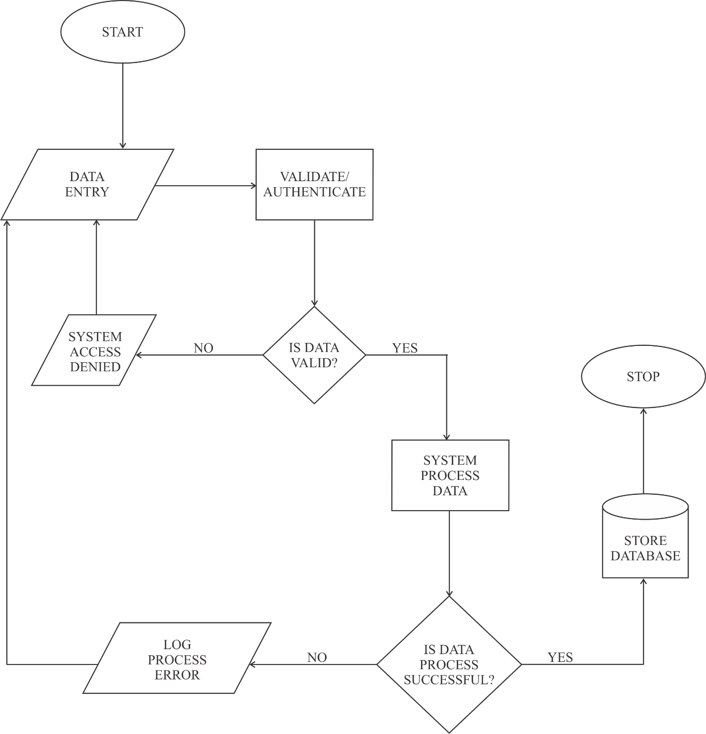

FIGURE: 1.2 FLOW OF DATA IN DATA PROCESSING MODULE
3.2 SYSTEM ARCHITECTURE
Below is the application architecture which shows a graphical representation of the application, views, and database. It also shows the connections and interactions that can be carried out in the system.

SUPER ADMIN PORTAL

ADMIN PORTAL

SUPER ADMIN LOGIN
ADMIN LOGIN

VIEW STUDENT

DATA PROCESSING & STORAGE
REGISTER &VIEW STAFF
DATABASE
REGISTER &VIEW STUDENT

STUDENT GPA

STUDENT REPORT

REGISTER & VIEW FACULTY

REGISTER & VIEW COURSE

FIGURE: 1.3 SYSTEM ARCHITECTURE
3.3 SYSTEM FLOWCHART
START
START

LOGIN SUCCESSFUL

SUPER ADMIN LOGIN
ADMIN LOGIN

NO
LOGIN SUCCESSFUL
NO

YES YES
VIEW STAFF, STUDENT, FACULTY, COURSE

VIEW STUDENT & REPORT

VIEW STUDENT & REPORT

CALCULTE STUDENT GPA

STOP

FIGURE: 1.4 SYSTEM FLOWCHART
CHAPTER FOUR
SYSTEM IMPLEMENTATION AND DESIGN
  - DESIGN STANDARDS
The new system is structured to work with the standard software development procedures. It is web based and has a relational database structure for storing the various activities involved. The Computerize Grade Point is placed in PHP, API & JAVASCRIPT codes for online access alongside with MySQL database.

    - ADMIN LOGIN AUTHENTICATION MANAGEMENT
Every user who wants to use this software (Grade Point System) by means of email address and password which is already created by the super administrator and is stored in the database. This authentication module can only access administrator and student who has register under administrator portal. This authentication form is required email as username and password.

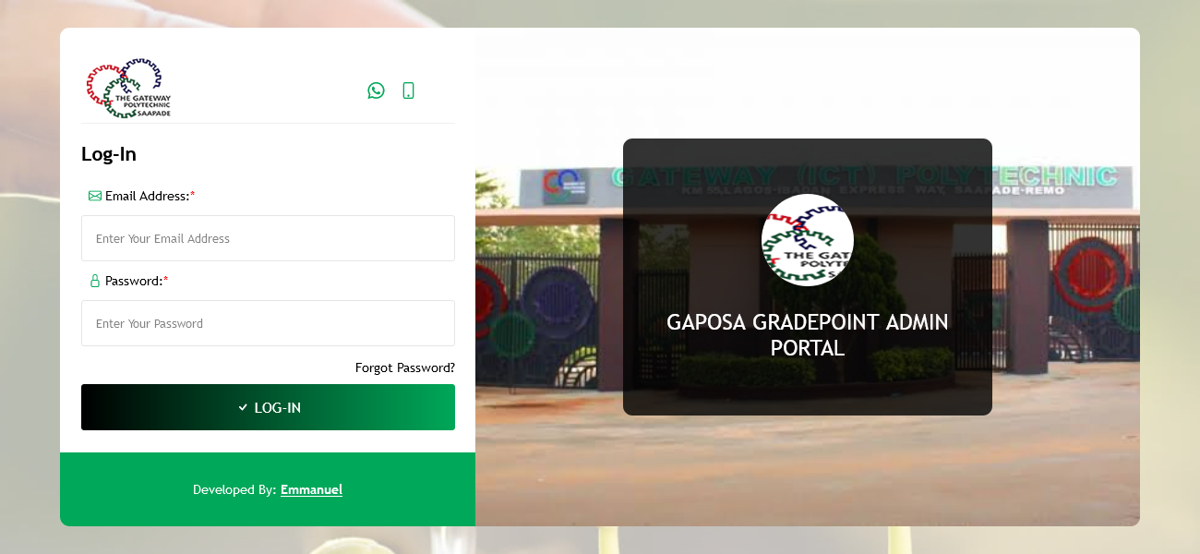

FIGURE: 1.5 AUTHENTICATION MANAGEMENT

4.1.2 THE SUPER ADMIINSTRATOR’S DASHBOARD PORTAL
The super administrators are the back-end of the software, they are the one who manage and manipulate every module in this page. They can register administrators as (staff), students, add departments, add courses and etc. Also they can assign course for staff and manipulate staff (update staff profile) and (update student profile).

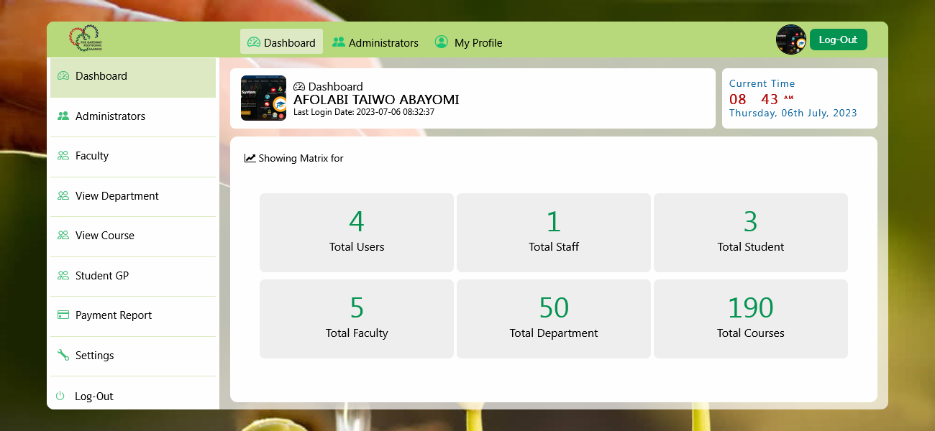

FIGURE: 1.6 ADMINSTRATOR’S DASHBOARD

4.1.3 ADMINSTRATOR’S REGISTRATION
Any administrators, student want to make use of this software (screen-class) he/she must register under super administrators. Every registration automatically the system will generate identity no for administrators (staff id no) and student (matric no) so that the system can count number of administrators and student that are registered.
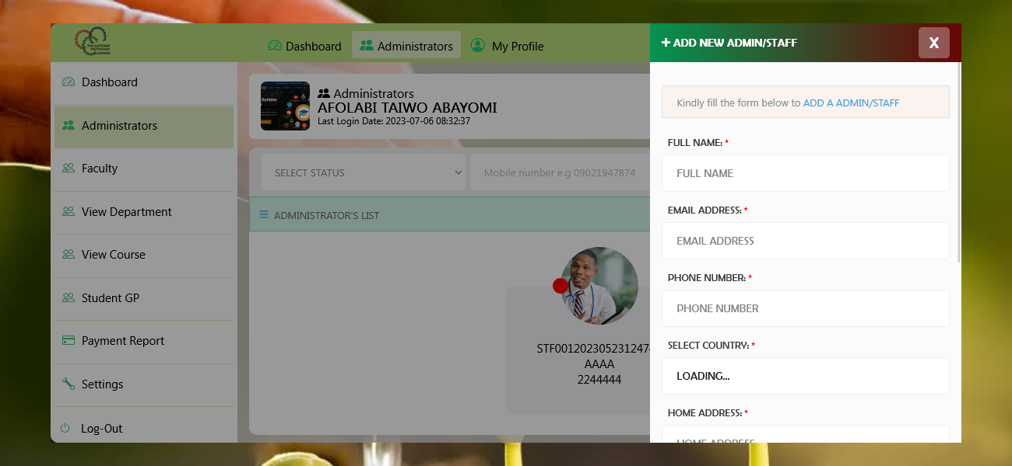

FIGURE: 1.7 ADMINSTRATOR’S REGISTRATION
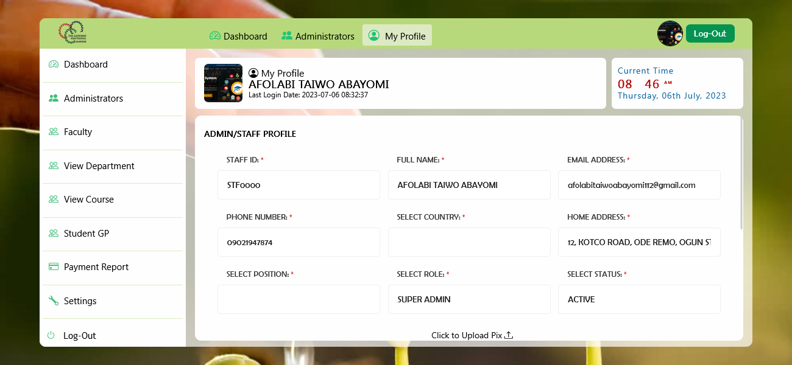

FIGURE: 1.9 STUDENT REGISTRATION

4.1.4 DATABASE DESIGN
MySQL database was used in the design. There are ten tables used in the design. The student table, staff table, course table, department table, faculty table, counter table, lectures table, week table, status table, period table.

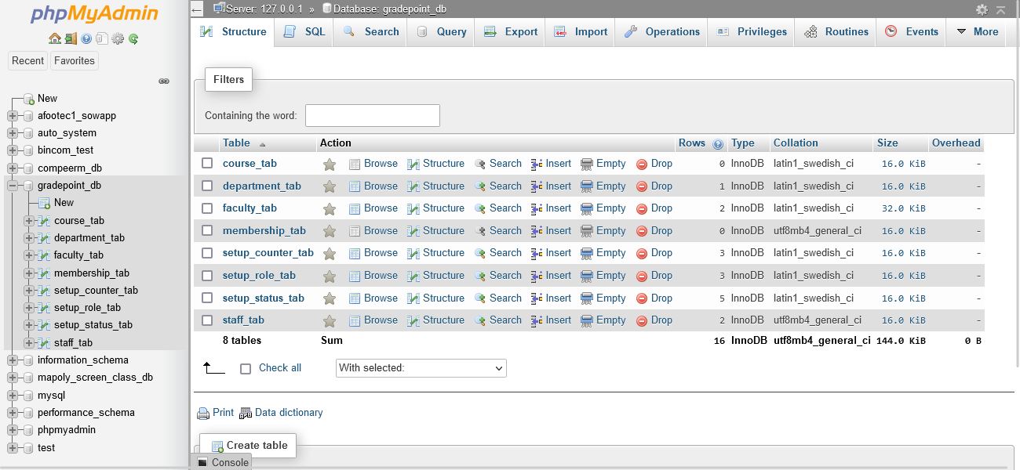

FIGURE: 1.8 DATABASE DESIGN

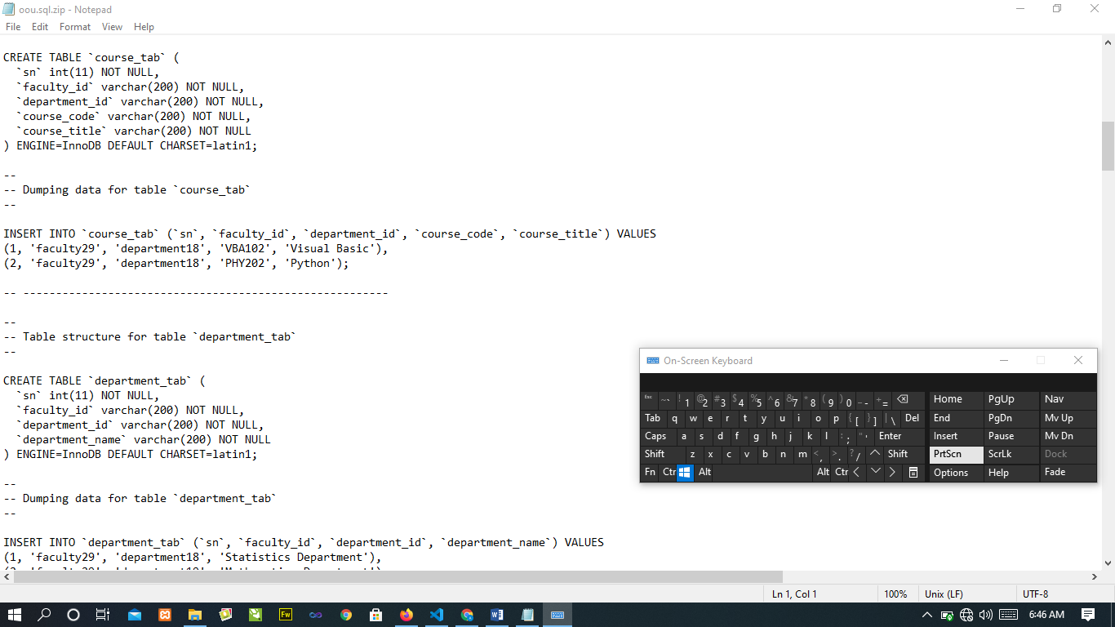

FIGURE: 1.15 MYSQL DATABASE DESIGN

4.2 SYSTEM REQIREMENT

Hardware Requirements

In the design, the software developed needs the following hardware for an effective and efficient operation of the new system.

Intel Computer System.
- At least 2GB RAM.
- Enhanced keyboard.
- At least 320GB hard disk.
- A colored monitor.
- An uninterruptible power supply (UPS) units
- LaserJet or DeskJet printer.

Software Requirements
The software requirements includes:-
1. A window XP or higher version for faster processing
- Database server (apache)
- Web server (apache)
- Graphical application (Corel draw)
- Dreamweaver 8.0
- Mozilla web browser
- Fire Fox web browser
- Chrome web browser

Operational Requirement
For the new system to be operational, Internet access is needed in the computer.
Personnel Requirement
A Computer system with internet access.

CHAPTER FIVE
SUMMARY, CONCLUSION AND RECOMMENDATIONS
5.1 SUMMARY
Having come to the completion of the project work, a lot of achievements was made and they include:
- Design and development of a school online grade point and evaluation system.
- To view list of administrator’s and student was also design.
- Question setting system was also designed.
- To add faculty, department, course was also design.
- To upload and view downloadable materials was also design
- Answer system was equally designed to enable the students supply their answers to questions.
- The use of PHP, JAVASCRIPT, CSS, API Integration codes to design a web application.
- The use of a database server was implemented.

5.2 CONCLUSION
With the advent of information technology in our developing and developed world, learning facilities are now on the increase. Also means of accessing the understanding rate is also fast increasing. Therefore, the online lecture and evaluation system as developed in this project will assist the users to test the knowledge of people around.
This adds a lot of advantage to the communication / training institutes as a package like this can be used to train the students online and test their knowledge and also adds value to education standard as it reduces examination malpractices.

5.3 RECOMMENDATION
Online Grade Point and Evaluation System is recommended to all who wants to be educated especially at the tertiary level as it is effective and of high standards.

REFERENCES

A, B. (2005). e-Learning and Distance Education. London: Oxford university press.
Allen, I. a. (2009). Online Education in the United States. New Jersey. Wiley publishing.
Edward. (2000). E-Learning Designing. Brussels: Sams publishing.
Graziadei. (1993). Virtual Instructional Classroom Environment in Science (VICES). Atlanta: Hila press.

Harasim, L. (1995). A Field Guide to Teaching and Learning Online. Cambridge: MIT Press.

Hebert. (2007). Five Challenges and Solutions in Online Music Teacher. London: Oxford university press.

Hiltz, S. (1990). Evaluating the Virtual Classroom. New York: St. Martin’s press.

Karrer, T. (2008). Corporate Long Tail Learning and Attention Crisis. California: Sun Microsystems, Inc.

Kerkman, L. (2004). Convenience of Online Education Attracts Midcareer. Students. Cambridge: MIT Press.

Mason. R, a. K. (1989). Computers and Distance Education. London: Oxford university press.

Means, B. T. (2009). Evaluation of Evidence-Based. Practices in Online Learning. USA: McGraw Hill companies.

Allen, I. and Seaman, J. (2009). Online Education in the United States. New Jersey: Wiley publishing.

Allen, I. and Seaman, J. (2003). The Quality and Extent of Online Education in the United States. New Jersey: Wiley publishing.
Bates, A. (2005). e-Learning and Distance Education. London: Oxford university press.
Edward, C. (2000). E-Learning Designing. Brussels: Sams publishing.
A cademy, S. (2013). Post-Utme-Questions-Answers-Baze-University. Samphina academy.

Academy, V. (2009). The History of Online Schooling. Visual Academy.
Connection’s. (2016). Main Benefits of Online School . Connection’s Academy.
Docsity. (2013). Exam Study and Advantages of Exampapers. Docsity.
James, A. (2014). Automated Students Management System. Oracle.
K., A. S. (2012). Student Management System.
Ngoma, S. (2019). Effectiveness of PastQuestion.
point, T. (2016). Tutorials point. Retrieved from https://www.tutorialspoint.com/sdlc/sdlc_agile_model.htm.
S., W. S. (2014). A Framework for Web-based Past Question System.
Spinuzzi, C. (2015). The methodology of participatory design. Technical communication.
UNESDOC. (2016). Digital Library. UNESDOC.
University, B. (2019). Exam Past Questions. Baze University.
University, N. e. (2020). Benefits of Online Learning. North eastern University.
Vecchioli, L. (2018). A Process for Evaluating Past Question.
Wayman, J. S. (2015). Software Enabling School Improvement through Analysis of Student Data.

Harasim, L. Hiltz, S. et al (1995). A Field Guide to Teaching and Learning Online. Cambridge: MIT Press.
APPENDIX
HOME PAGE SOUCE CODE

<!DOCTYPE html>
<html>
<head>
<title>MAPOLY - ScreeClass</title>
<?php include 'reference.php' ?>
</head>
<body>
<?php include 'header.php' ?>

<div class="background-image-div">
<?php include 'slide.php' ?>
</div>

<footer>
<div class="overlay-div animated animated zoomIn animated">
<a href="login.php"><button class="main-btns no-right">ADMIN</button></a>

<a href="login.php"><button class=" btn-cl">SUPER ADMIN</button></a>
<a href="login.php"><button class="main-btns no-right">STUDENT</button></a>
</div>
</footer>

</body>
</html>
ADMIN PAGE SOUCE CODE

!DOCTYPE html PUBLIC "-//W3C//DTD XHTML 1.0 Transitional//EN" "http://www.w3.org/TR/xhtml1/DTD/xhtml1-transitional.dtd">
<html lang="en" xmlns="http://www.w3.org/1999/xhtml">
<head>
<?php require_once ("reference.php")?>
<title>Administrative Portal | GAPOSA – Grade Point System</title>

</head>
<body
<?php include 'header.php' ?>
<div class="dashboard-main-div">
<?php include 'admin-reference.php' ?>
<div class="right-sided-div">
<div class="bg-image-div">
<div class="bg-cover">
<div class="dashboard-overall">
<div class="dashboard-admin-text">
<span class="dashboard">
<i class="fa fa-dashboard"></i>
Dashboard
</span>
<br/>
<span class="admin-portal">
Administrative Portal
</span>
</div>

<div class="current-time">
<span class="text">
Current Time
</span><br/>
<span class="time" id="datetime">
<?php echo date("h:i:s") ?> <sup> <?php echo date("A") ?> </sup>
</span><br/>
<span class="text">
<?php $date = date("l, dS F, Y");
echo $date
?>
</span>
</div>
<div class="user-details">
<div class="picture-div">
<img id="ImageDisplay" name="ImageDisplay" alt="Passport"
<?php
if ($passport == ''){
?>
src="images/po.png"
<?php
}else{
?>
src="../admin/staff-picture/<?php echo $passport ?>"
<?php } ?>
>
</div>
<div class="welcome-text">
Welcome Back!
<h1><?php echo $lastname ?> <?php echo $firstname ?></h1>
<span class="login-date"><i class="fa fa-clock"></i>
Last Login Date
<span> | </span>
2021-11-04 18:52:11
</span>
</div>
</div>
</div>
</div>
</div>
<div class="main-displayed-div">
<a href="staff-list.php"><div class="main-div-proper staffs">
<div class="inner-div">
<?php
$staff_count_query = mysqli_query ($conn,"SELECT * FROM `counter_tab` WHERE counter_id='STAFF'") or die ('cannot select staff table');
$staff_count=mysqli_fetch_array($staff_count_query);
$staff=$staff_count['counter_value'];
?>
<i class="fa fa-user"></i>
<span class="number">

<?php echo $staff ?>
</span><br/>
Staffs
</div>
</div></a>
<div class="main-div-proper students" onclick="_view_student()">
<div class="inner-div">
<?php
$staff_count_query = mysqli_query ($conn,"SELECT * FROM `counter_tab` WHERE counter_id='STUDENT'") or die ('cannot select staff table');
$staff_count=mysqli_fetch_array($staff_count_query);
$student=$staff_count['counter_value'];
?>
<i class="fa fa-users"></i>
<span class="number">
<?php echo $student ?>
</span><br/>
Students
</div>
</div>
<a href="faculty-table.php"><div class="main-div-proper faculties">
<div class="inner-div">
<?php
$staff_count_query = mysqli_query ($conn,"SELECT * FROM `counter_tab` WHERE counter_id='FACULTY'") or die ('cannot select staff table');
$staff_count=mysqli_fetch_array($staff_count_query);
$faculty=$staff_count['counter_value'];
?>
<i class="fa fa-building"></i>
<span class="number">
<?php echo $faculty ?>
</span><br/>
Faculty
</div>
</div></a>

<div class="main-div-proper courses" onClick="_view_course();">
<div class="inner-div">
<?php
$staff_count_query = mysqli_query ($conn,"SELECT * FROM `counter_tab` WHERE counter_id='COURSE'") or die ('cannot select staff table');
$staff_count=mysqli_fetch_array($staff_count_query);
$courses=$staff_count['counter_value'];
?>
<i class="fa fa-book"></i>
<span class="number">
<?php echo $courses ?>
</span><br/>
Courses
</div></div> </div>
</body>
</html>

